## How to Use Value measure tool

### Prerequisite

1. Ubuntu or Mac machine or windows 10 with docker
2. Docker , docker-compose
3. You need to figure out in your file system where you can put your code for analysis

------------------------------------for mac users---------------------------------------------------------------------

lets use /Users

To check shared directories You can check like below (Docker->preferences)

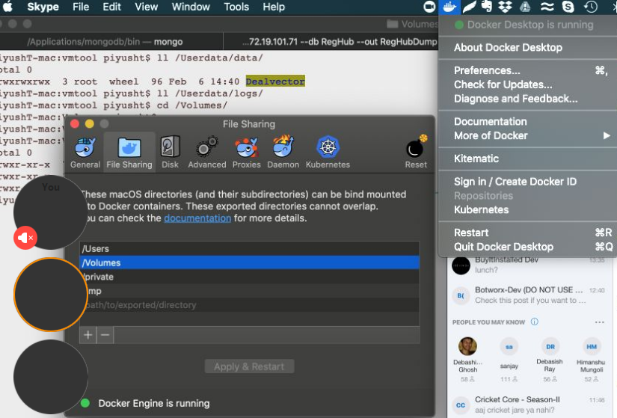

If /Users is not present then lets pick another but In this document we are referring /Users and you can replace that with your pick

---------------------------------------End for mac users -----------------------------------------------------------

For Ubuntu users it could be /data

1. All Repositories in one directory in /data/{projectname}/repos/

For example if my project name is awesome_project and I have two repos client, server

Then there should be two directories like below

/data/ awesome_project /repos/client

/data/ awesome_project /repos/server

Note:- Mac users should use /Users/data and /Users/logs

1. Talentica network
2. All repos should be clean (no target , bin , node_module directories, thirdparty, dependencies)
3. All repos should be pull only from master(or main release branch)
4. /data must have full permission (777) for current user
5. Knowledge of docker and compose

### There are three components

1. Value measure Admin Portal (To run process , configurations etc.)
2. Value measure tool ( a docker containerized app to be run in your system)
3. Cicero (Report Portal to view your reports)

### Step 1:- Registering your project with Value measure Admin Portal

1.Open https://172.19.101.120:3333/index

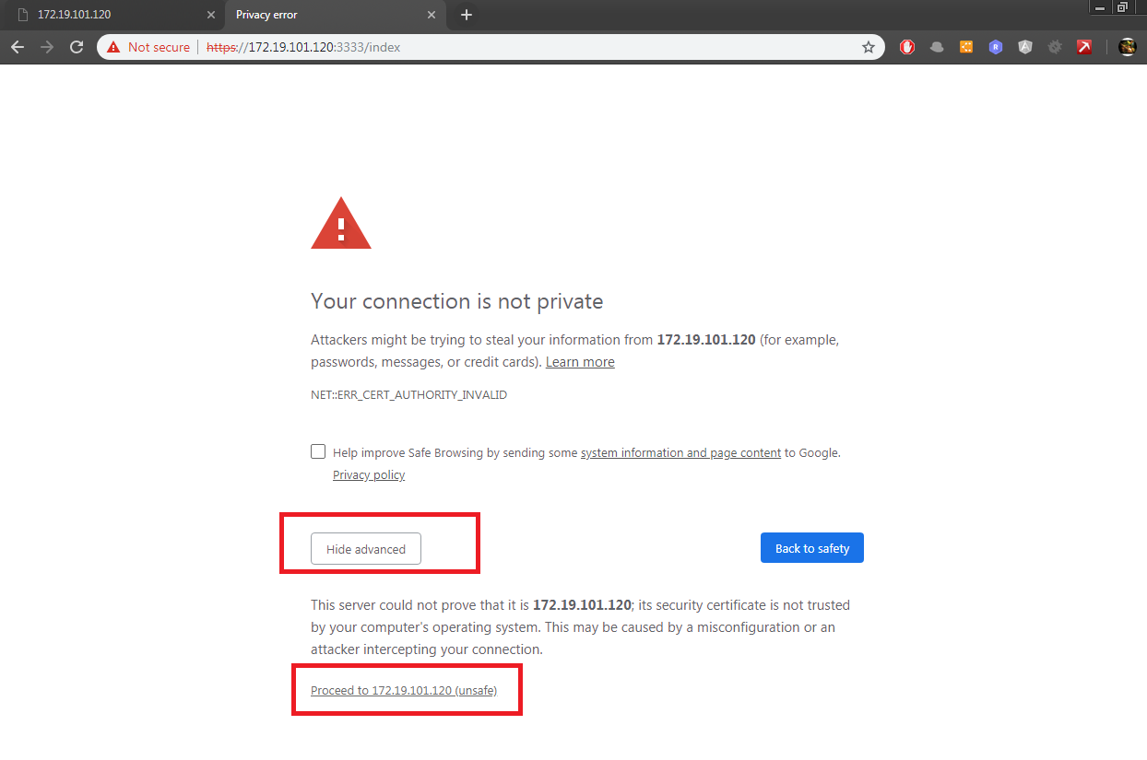

2. Proceed with unsafe

3. Login with your standard talentica office ( same as office365) credentials.

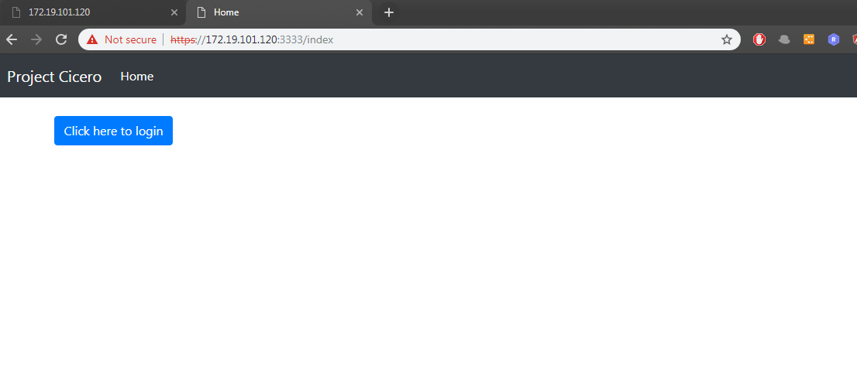

4. Open <https://172.19.101.120:3000/> , repeat step 2

5. click on execution , click on create new project , provide project name and submit

6. Send your project name and email to [ratneshp@taletnica.com](mailto:ratneshp@taletnica.com) or skype ratneshsinghparihar (preferred and quick) to complete the registration

### Step 2:- Running Value Measure Tool in your machine

1. Check prerequisite
2. /data/{project }/ repos should have all clean repositories
3. Project name must be same as used in registration process
4. Create a directory with full permission for docker user example /home/vmtool
5. chmod -R a+rwX /data (for mac user chmod -R a+rwX /Users/data)
6. chmod -R a+rwX /logs (for mac user chmod -R a+rwX /Users/logs)
7. Run cd /home/vmtool
8. RUN sudo docker login dockertal.azurecr.io
9. User name :- dockertal
10. Password :- Pz5=1OVCmob3STyFNliMmfZJW3aVM7E4
11. Don’t share above with anyone ( cicero tool is IP of Talentica software and this image is not distributable in any case)
12. RUN sudo docker pull dockertal.azurecr.io/cicero
13. Download compose file from <https://172.19.101.120:3000/docker-compose.yml>

into your /home/vmtool/ directory and edit the project name like below

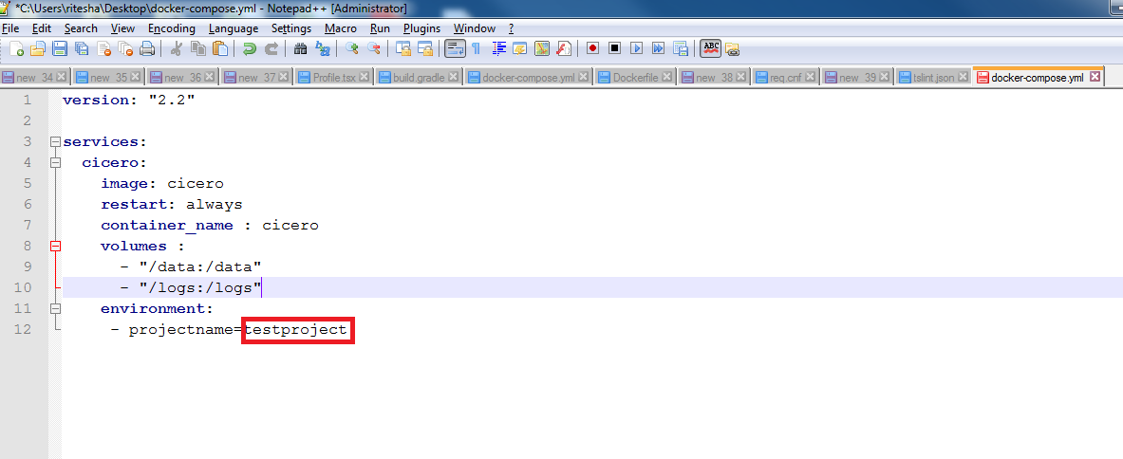

Mac users need to update the volumns section like below

* “/Users/data” : “/data”
* “/Users/logs”:”/logs”

1. RUN sudo docker-compose up –d
2. RUN sudo docker-compose logs –f

Now Value Measure tool has been setup and running in background ,

To stop docker use sudo docker-compose down

### Step 3:- Executing your Project using VM admin tool

1.Repeat 1 to 4 from Step 1

2. From Project dropdown select your project 🡪 select execution 🡪 Execute SP

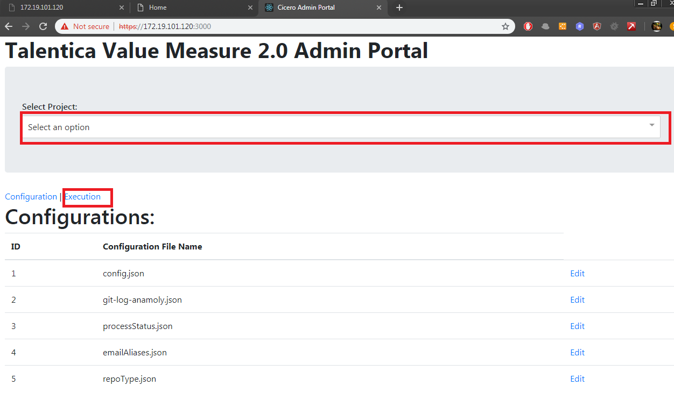

1. Set both mainGitAnalysis and prepareMainStatus from 1 to 0 and submit, This will generate all configuration required to process, Once submit you can check your progress in sudo docker-compose logs –f

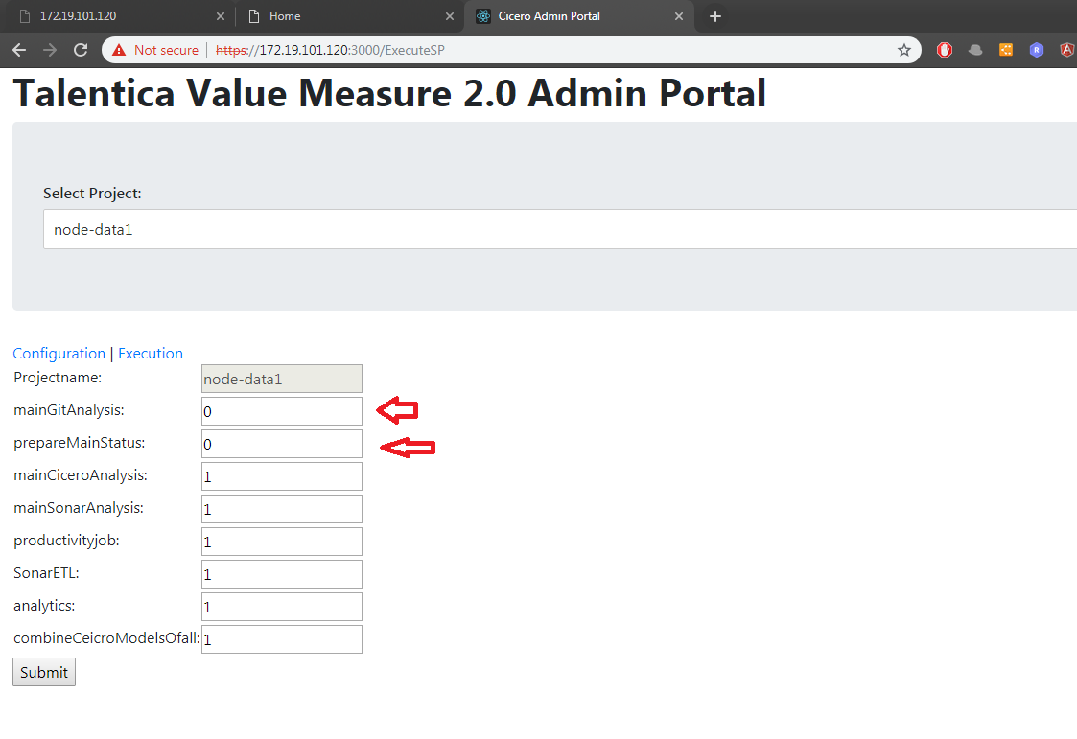

1 means It has been executed or never executed before

0 means you want to execute a process

1. Once above step done , click in Configuration and setup repotye and email aliases

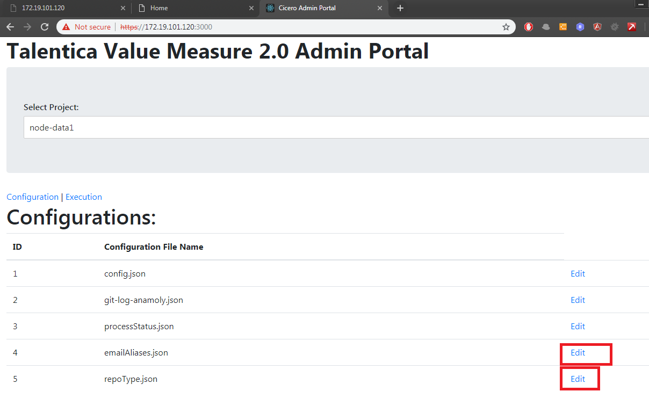

### Instructions: -

**repoType** :- provide type of repository (js ,ts, java ) if not know or multiple languages just put js .

**emailAliases** :- many times developers use multiple git accounts , but in reports we should have single developer , this configuration solve this problem , provide same aliases for multiple git account of users.

------------------------------For mac/linux users-------------------------------------------------------------------

**config.json** Edit, go to sonar command and replace with following and save

"../../sonar-scanner/bin/sonar-scanner" -Dsonar.host.url=http://172.19.101.120:9393 -Dsonar.login=2dcd3909dd3091d5b81cf5fbe1eede589bf8f221 -Dsonar.java.binaries=../../sonar-scanner/lib/ -Dsonar.projectName=$reponame -Dsonar.projectKey=$reponame -Dsonar.sources=./ -Dsonar.language=$repotype

-------------------------- For mac/linux users-------------------------------------------------------------------

1. Once done , click execution 🡪 execute SP -> set mainCiceroAnalysis as 0 and submitt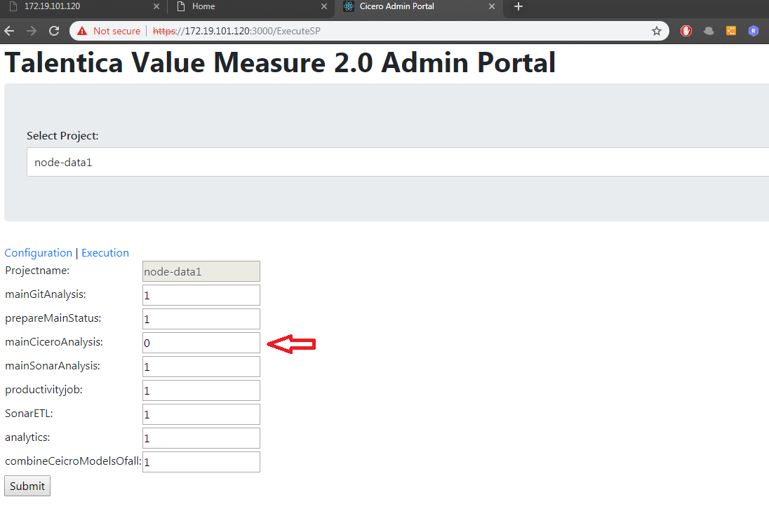

This is a long running process and took time , check docker logs for and issue

1. Once done do same for mainSonarAnalysis
2. Next process can be set 0 all together and submit

## Step 4: View your reports in Cicero Portal

1. Inside your /data/{project}/ directory there will be two directories cicer-all and reports, zip them into a single file
2. Email it to [ratneshp@talentica.com](mailto:ratneshp@talentica.com) or use skype
3. It will take 5 min to upload your changes
4. Log in into <https://172.19.101.120:3333/index>
5. Select your project and Dashboard1 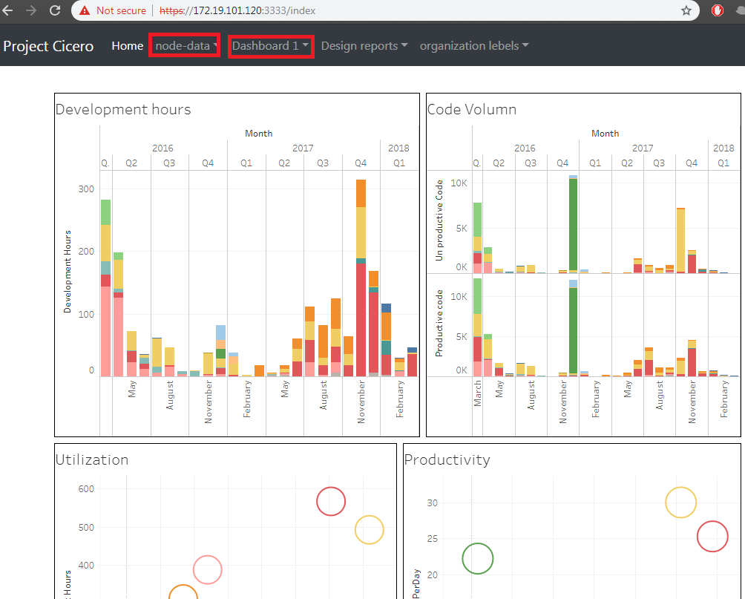

in next dropdown